**Commercial goat farming: tips and tricks**

***By: Khalid Sultan, Drs,***

***MGR* Reliance B.C.T.S.**

Commercial goat farming under intensive system has been gaining momentum for the past few years. This type of business has been deriving many modern farmers, professionals, ex-serviceman, unemployed educated youths etc. to take up the goat enterprise on a commercial scale.

High demand for milk products with potential of good economic returns to their initial investment are essential factors behind the booming of commercial goat farming.

***BENEFITS OF COMMERCIAL GOAT FARMING:***

1 Commercial goat farming is a great and guaranteed profitable business idea

2. Capital required for this business is comparatively less than other business opportunities. Even you can start with a little amount of goats. And by proper care and management, you can grow your business to the next level within one year or two.

3. Goats produce kids more than once a year. So, if you start with a few goats then you will be able to grow your business fast.

4. Goats require housing/sheltering facilities less than other livestock animals.

5. It is very easy to maintain goats and maintenance costs are also less.

6. Goats require less labour costs.

7. Great business idea for unemployed educated youths, women, ex-serviceman and professionals.

8. Women can also perform this business by setting up small scale commercial farm. This will help them by providing economic support.

9. Especially, the unemployed educated youths can create a great business and employment opportunities by establishing commercial goat farming.

10. Government of almost all countries provide necessary training and other facilities for establishing this type of business.

11. Many local, Govt. and international banks are interested in investing on this types of business with a very little terms and condition. Some Govt. bank provide loan facility with a very little or no interest.

12. Commercial goat farming is a great business idea with good returns of investment ratio (ROI).

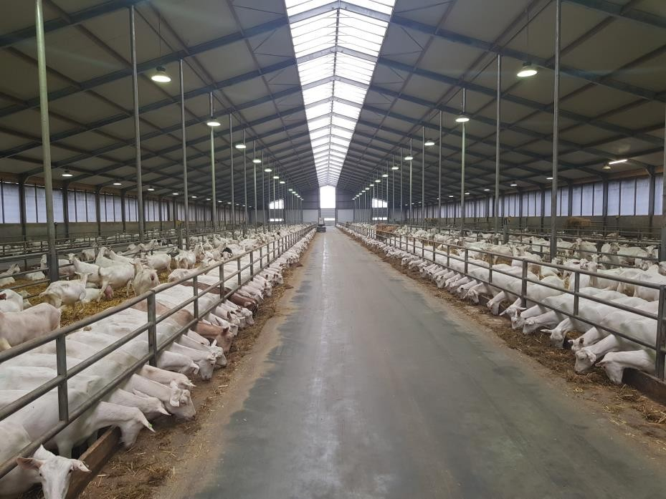

***SETTING UP A COMMERCIAL FARM:***

Setting up a commercial goat farm doesn’t require any hard core plan. Just follow the step by step process very carefully and you will be able and set up a commercial goat farm. And if you can manage everything perfectly, then you will definitely be able to earn high profit from your farm.

***LOCATION:***

It is very important to select a suitable place for setting up commercial farm with all types of facilities for goats. Wherever your farm is located, you have to ensure all types of facilities are available in your selected locations or areas. The essential facilities for establishing a commercial goat farm are listed below.

1. Great source of clean and fresh water. Because, clean and fresh water keeps your animal healthy. Always provide them sufficient clean and fresh water according to their daily needs. A great source of water can be made by setting up a tube well, pond or any other types of water reservoir. Always keep water inside the house and many places of your farm.

2. Select the farm location near to villages. By setting your farm near to villages, you will be able to get labour for your farm easily and cheaply.

3. Good transportation system is a must while selecting land for farm. Good transportation system will help you to keep good relation with your nearest market and other source.

4. Ensure the location is chaos, noise and all types of pollution free.

5. Ensure veterinary service is available near your farm. Very close veterinary service will reduce your losses and tension if something goes wrong.

***BREEDS:***

Choosing the proper goat breeds for your commercial farm is very important. There are numerous breeds around the world. Some of them are highly meat productive, some are famous for milk production, some goat breeds produces high quality skins and fiber. Saanen is a world famous dairy goat breed of Switzerland. But it is very suitable for commercial dairy goat farming around the globe. A Saanen doe can produces about 3-4 kg milk daily.

***HOUSING:***

Good housing system is a must for commercial goat farming. A good designed house with all types of accommodation facilities, influence the total production and profit from commercial goat farming.

1. On an average, 1.5-2.0 squire meter housing space is required per goat. So, build your house according to the number of goats. Inside the house, keep separate room for buck and does.

2. Never keep bucks and does together. You can also make numerous separate house for keeping them permanently separate from each other. Make a separate room for the kids also.

3. For commercial dairy goat farming, making an extra room for milking the goats will be effective.

4. While making the house, ensure availability of sufficient space required by the goats. Make proper ventilation system. For ventilation, you can use electric fans or make big sized window while making the house.

5. Make a suitable drainage system, so that you can clean the house easily. While building house for goats, follow the tips below.

6. Select a higher place for building house. This will help you to keep the house always dry.

7. Always keep the floor of the house dry.

8. Ensure sufficient flow of fresh air and light.

9. Make proper temperature and moisture controlling system inside the house.

10. Prevent damping condition. Because this can causes various types of diseases.

11. Always keep sufficient clean and fresh water inside the house.

***FEEDING:***

Feeding is the most important part of commercial goat farming. High commercial production and maximum profit is mostly dependent on feeding high quality fresh and nutritious food. Along with enough regular green food you have to provide nutritious complementary food regularly. Providing fresh and nutritious food ensures higher production and profit form commercial goat farming. Always ensure availability of all types of nutritional ingredients in the complementary food. See goat feed, what to feed goats. http://www.roysfarm.com/what-to-feed-goats/

http://www.roysfarm.com/goat-feed/

1. Always observe the health condition of goats. If there any thin or weak goats, then separate those and give them some extra nutritious food.

2. Along with good feeding, try to understand whether the goats are diseases free or not. If any goats get affected by any diseases, then give them treatment first along with providing good food.

3. Store your goat feed in cool and safe place.

4. If you want to change the food habit of goat then do it slowly. Never change the feeding habit suddenly. Because, by changing feeding habit suddenly, your goat may lose interest taking food. This will result serious health hazard.

5. Ensure colostrum for kids after their birth.

6. Keep numerous water pot inside the house. But, never put water and food basket at same place.

7. Adequate green feed, vitamins, minerals, fresh and clear water, balanced diet is the key to success in commercial goat farming.

***VETERINARY SERVICES:***

In modern goat farming methods, the producers are very conscious about their goat’s health. And it is very necessary for commercial goat farming. Although diseases are less in goats. But, you have to ensure the availability of proper and sufficient veterinary service in your farm. It will be better if your farm located near to any veterinary service centre. For commercial goat farming purpose, you also have to store the necessary medicines and vaccines in your farm. If anyhow something goes wrong, then you will be able to provide first aid.

REGULAR CARE

Never delay or stop caring your goats. Always provide them good care and management. Proper care and management can ensure maximum production and high profit from commercial goat farming business. For proper care and management do the above process perfectly.

***MARKETING:***

This is the easiest but most important part of commercial goat farming. If everything goes well and if you get sufficient production then it’s time to market your products. For small and medium commercial goat producer try first your local market, then big markets in your country.